User manual

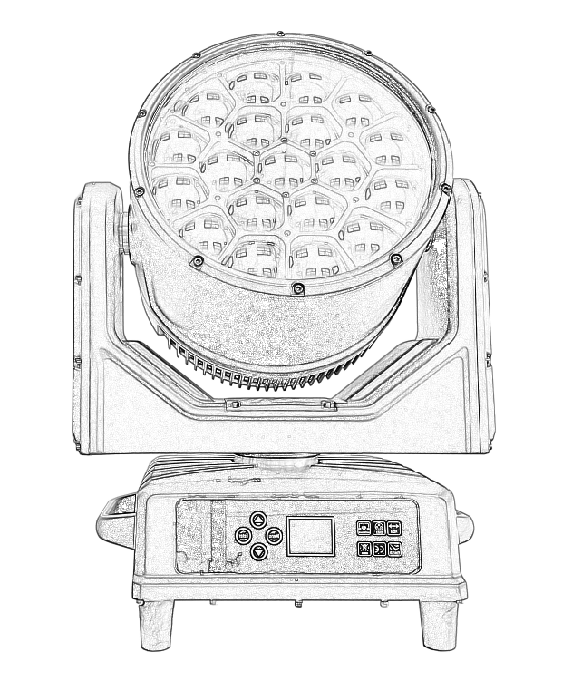
IP-1940BL
Please read the instructions carefully before use

TABLE OF CONTENTS
- Safety Instructions……………………………………………………………………………3
- Technical Specifications…………………………………………………………………………4
- Control Menu ……………………………………………………………………………………5-6
- DMX Channels …………………………………………………………………………………6-11
- Dimension …………………………………………………………………………………………11
- Trouble Shooting…………………………………………………………………………………12
- Fixture Cleaning………………………………………………………… ………………………12

STATEMENT
The product has well capability and intact packing when leave factory. All of the user should comply with warning item and manual, any misuse cause of the damages are not included in our guarantee, and also can not be responsible for any malfunction & problem owing to ignore the manual.

1.Safety Instructions
Please keep this User Guide for future consultation. If you sell the unit to another user, be sure that they also receive this instruction booklet.
•Unpack and check carefully there is no transportation damage before using the unit.
•Before operating, ensure that the voltage and frequency of power supply match the power requirements of the unit.
•It’s important to ground the yellow/green conductor to earth in order to avoid electric shock.
•The unit is for indoor use only. Use only in a dry location.
•The unit must be installed in a location with adequate ventilation, at least 50cm from adjacent surfaces. Be sure that no ventilation slots are blocked.
•Disconnect main power before replacement or servicing.
•Make sure there are no flammable materials close to the unit while operating as it is fire hazard.
•Use safety cable when fixes this unit. DO NOT handle the unit by taking its head only, but always by taking its base.
•Maximum ambient temperature is Ta: 40℃. DO NOT operate it where the temperature is higher than this Unit surface temperature may reach up to 85℃. DO NOT touch the housing bare-hand during its operation. Turn off the power and allow about 15 minutes for the unit to cool down before replacing or serving.
•the event of serious operating problem, stop using the unit immediately.Never try to repair the unit by yourself. Repairs carried out by unskilled people can lead to damage or malfunction. Please contact the nearest authorized technical assistance center. Always use the same type spare parts.
•DO NOT touch any wire during operation as high voltage might be causing electric shock.
Warning:
•To prevent or reduce the risk of electrical shock or fire, do not expose the unit to rain or moisture.
•The housing, the lenses, or the ultraviolet filter must be replaced if they are visibly damaged.
Caution:
•There are no user serviceable parts inside the unit. DO NOT open the housing or attempt any repairs yourself. In the unlikely event your unit may require service, please contact your nearest dealer.

Installation:
•The unit should be mounted via its screw holes on the bracket. Always ensure that the unit is firmly fixed to avoid vibration and slipping while operating. And make sure that the structure to which you are attaching the unit is secure and is able to support a weight of 10 times of the unit’s weight. Also always use a safety cable that can hold 12 times of the weight of the unit when installing the fixture.
•The equipment must be fixed by professionals. And it must be fixed at a place where is out of the touch of people.

2.Technical Specifications
Voltage: AC100V～240V 50-60HZ
Power: 760W
LED Source: 19*40W RGBW 4-in-1 LED
Zoom angle: 4-55°
Wash+beam+bee eye graphics special effect
Strobe: 0-25Hz
Control: DMX512/Auto Run/Master-Slave/Music
DMX Channels:2 2 CH /3 6 CH/7 9 CH/9 8 CH/9 3 CH
Dimmer: 0-100% linear dimmer
Pan: 540°+16 bit fine
Tilt: 270°+16 bit fine
Display: LCD colorful display
IP rate: IP66
NW:16kg

3.Control Menu
Main menu function | Address Settings | 001 - 512
Main menu function | Lighting settings | Channel Mode | 2 2 CH /3 6 CH/7 9 CH/9 8 CH/9 3 CH
Main menu function | Lighting settings | Operation Mode | DMX / Self-propelled
Main menu function | Lighting settings | Horizontal Invert | Open / Close
Main menu function | Lighting settings | Vertical Flip | Open / Close
Main menu function | Lighting settings | Fan control | Quiet/Low/Medium/High
Main menu function | Lighting settings | Dimming curve | Linear/reverse pointing curve/positive pointing curve/S curve
Main menu function | Lighting settings | Fast light collection | Open / Close
Main menu function | Lighting settings | No DMX status | Clear/Hold
Main menu function | Manual Control | red | 000 - 255
Main menu function | Manual Control | Red fine tuning | 000 - 255
Main menu function | Manual Control | green | 000 - 255
Main menu function | Manual Control | Green fine tuning | 000 - 255
Main menu function | Manual Control | … | …
Main menu function | Lighting information | Time Information | Boot time
Main menu function | Lighting information | Time Information | Total time
Main menu function | Lighting information | Time Information | Number of boot times
Main menu function |  | Sensor detection | Level sensor
Main menu function |  | Sensor detection | Vertical Sensing
Main menu function |  | Sensor detection | Focus sensor
Main menu function |  | Sensor detection | Rotation Sensing
Main menu function |  | Sensor detection | Temperature Sensing
Main menu function |  | Software Version | Show version
Main menu function |  | Software Version | Motor version
Main menu function |  | Software Version | Dimming version
Main menu function |  | Software Version | Web version
Main menu function | Factory settings | Password Input | 000 - 255
Main menu function | Factory settings | Horizontal correction | 000 - 255
Main menu function | Factory settings | Vertical Correction | 000 - 255
Main menu function | Factory settings | Magnification Correction | 000 - 255
Main menu function | Factory settings | Zoom in and rotate | 000 - 255
Main menu function | Factory settings | Red Correction | 000 - 255
Main menu function | Factory settings | … | …
Main menu function | Factory settings | … | …
Main menu function | Lamp reset | Reset All | Execute/Cancel
Main menu function | Lamp reset | Factory settings | Execute/Cancel
Main menu function | Display Settings | Language settings | Chinese/ English
Main menu function | Display Settings | Display Invert | Normal/Reverse
Main menu function | Display Settings | Display Mode | 60s / Constantly on

4.DMX Channels
22CH
CH | DMX Value | Details
1 | 0-255 | Red dimmer
2 | 0-255 | Red fine tuning
3 | 0-255 | green
4 | 0-255 | Green fine tuning
5 | 0-255 | blue
6 | 0-255 | Blue Fine Tuning
7 | 0-255 | White
8 | 0-255 | White fine tuning
9 | 0-255 | Color temperature control
10 | 0-255 | Color Macros
11 | 0-255 | Strobe
12 | 0-255 | Dimming
13 | 0-255 | Dimming fine-tuning
14 | 0-255 | level
15 | 0-255 | Horizontal fine-tuning
16 | 0-255 | vertical
17 | 0-255 | Vertical fine adjustment
18 | 0-255 | Function
19 | 0-255 | Reset
20 | 0-255 | Zoom
21 | 0-255 | Rotation
22 | 0-255 | Reserve

3 6 CH

CH | DMX Value | Details
1 | 0-255 | red
2 | 0-255 | Red fine tuning
3 | 0-255 | green
4 | 0-255 | Green fine tuning
5 | 0-255 | blue
6 | 0-255 | Blue Fine Tuning
7 | 0-255 | White
8 | 0-255 | White fine tuning
9 | 0-255 | Color temperature control
10 | 0-255 | Color Macros
11 | 0-255 | Strobe
12 | 0-255 | Dimming
13 | 0-255 | Dimming fine-tuning
14 | 0-255 | level
15 | 0-255 | Horizontal fine-tuning
16 | 0-255 | vertical
17 | 0-255 | Vertical fine adjustment
18 | 0-255 | Function
19 | 0-255 | Reset
20 | 0-255 | Zoom
21 | 0-255 | Rotation
22 | 0-255 | Front layer selection
23 | 0-255 | Front layer speed
24 | 0-255 | Front layer fade
25 | 0-255 | Front layer red
26 | 0-255 | Front layer green
27 | 0-255 | Front blue
28 | 0-255 | Front layer white
29 | 0-255 | Front layer dimming
30 | 0-255 | Back layer dimming
31 | 0-255 | Front layer changes
32 | 0-255 | Front layer density
33 | 0-255 | Front layer strobe
34 | 0-255 | Back layer strobe
35 | 0-255 | Back layer selection
3 6 | 0-255 | Reserve

7 9 CH
CH | DMX Value | Details
1 | 0-255 | red
2 | 0-255 | Red fine tuning
3 | 0-255 | green
4 | 0-255 | Green fine tuning
5 | 0-255 | blue
6 | 0-255 | Blue Fine Tuning
7 | 0-255 | White
8 | 0-255 | White fine tuning
9 | 0-255 | Color temperature control
10 | 0-255 | Color Macros
11 | 0-255 | Strobe
12 | 0-255 | Dimming
13 | 0-255 | Dimming fine-tuning
14 | 0-255 | level
15 | 0-255 | Horizontal fine-tuning
16 | 0-255 | vertical
17 | 0-255 | Vertical fine adjustment
18 | 0-255 | Function
19 | 0-255 | Reset
20 | 0-255 | Zoom
21 | 0-255 | Rotation
22 | 0-255 | Red 1
23 | 0-255 | Green 1
24 | 0-255 | Blue 1
… | 0-255 | red…
… | 0-255 | green…
… | 0-255 | blue…
76 | 0-255 | Red 19
77 | 0-255 | Green 19
78 | 0-255 | Blue 19
79 | 0-255 | ...

9 8 CH
CH | DMX Value | Details
1 | 0-255 | red
2 | 0-255 | Red fine tuning
3 | 0-255 | green
4 | 0-255 | Green fine tuning
5 | 0-255 | blue
6 | 0-255 | Blue Fine Tuning
7 | 0-255 | White
8 | 0-255 | White fine tuning
9 | 0-255 | Color temperature control
10 | 0-255 | Color Macros
11 | 0-255 | Strobe
12 | 0-255 | Dimming
13 | 0-255 | Dimming fine-tuning
14 | 0-255 | level
15 | 0-255 | Horizontal fine-tuning
16 | 0-255 | vertical
17 | 0-255 | Vertical fine adjustment
18 | 0-255 | Function
19 | 0-255 | Reset
20 | 0-255 | Zoom
21 | 0-255 | Rotation
22 | 0-255 | Red 1
23 | 0-255 | Green 1
24 | 0-255 | Blue 1
25 | 0-255 | White 1
26 | 0-255 | Red 2
27 | 0-255 | Green 2
28 | 0-255 | Blue 2
29 | 0-255 | White 2
… | 0-255 | red…
… | 0-255 | green…
… | 0-255 | blue…
… | 0-255 | blue…
94 | 0-255 | Red 19
95 | 0-255 | Green 19
96 | 0-255 | Blue 19
97 | 0-255 | White 19
98 | 0-255 | ...
9 3 CH
CH | DMX Value | Details
1 | 0-255 | red
2 | 0-255 | Red fine tuning
3 | 0-255 | green
4 | 0-255 | Green fine tuning
5 | 0-255 | blue
6 | 0-255 | Blue Fine Tuning
7 | 0-255 | White
8 | 0-255 | White fine tuning
9 | 0-255 | Color temperature control
10 | 0-255 | Color Macros
11 | 0-255 | Strobe
12 | 0-255 | Dimming
13 | 0-255 | Dimming fine-tuning
14 | 0-255 | level
15 | 0-255 | Horizontal fine-tuning
16 | 0-255 | vertical
17 | 0-255 | Vertical fine adjustment
18 | 0-255 | Function
19 | 0-255 | Reset
20 | 0-255 | Zoom
21 | 0-255 | Rotation
22 | 0-255 | Front layer selection
23 | 0-255 | Front layer speed
24 | 0-255 | Front layer fade
25 | 0-255 | Front layer red
26 | 0-255 | Front layer green
27 | 0-255 | Front blue
28 | 0-255 | Front layer white
29 | 0-255 | Front layer dimming
30 | 0-255 | Back layer dimming
31 | 0-255 | Front layer changes
32 | 0-255 | Front layer density
33 | 0-255 | Front layer strobe
34 | 0-255 | Back layer strobe
35 | 0-255 | Back layer selection
36 | 0-255 | Red 1
37 | 0-255 | Green 1
38 | 0-255 | Blue 1
… | 0-255 | red…
… | 0-255 | green…
… | 0-255 | blue…
… | 0-255 | blue …
90 | 0-255 | Red 19
91 | 0-255 | Green 19
92 | 0-255 | Blue 19
93 | 0-255 | ...

5.Dimension
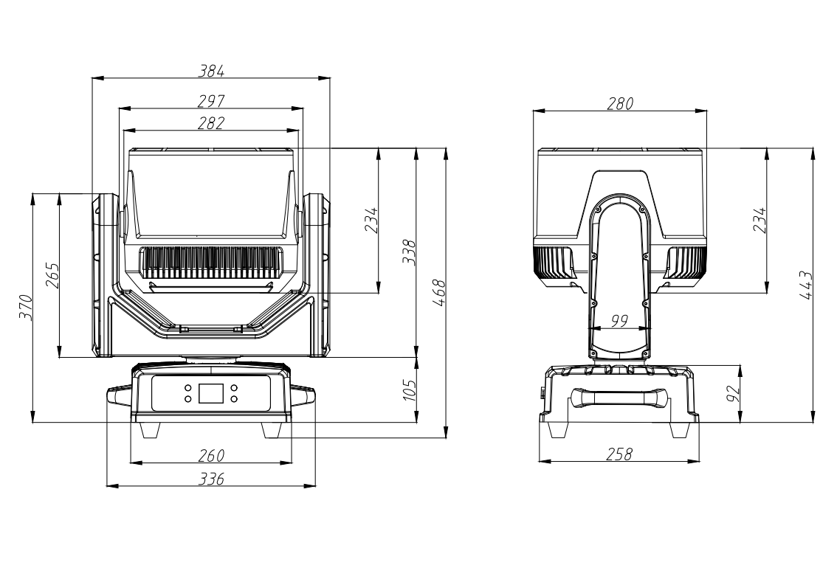

6.Trouble Shooting
Following are a few common problems that may occur during operation. Here are some suggestions for easy troubleshooting:

A. The unit does not work, no light and the fan does not work
1. Check the connection of power and main fuse.
2. Measure the mains voltage on the main connector.
3. Check the power on LED.

B. Not responding to DMX controller
1. DMX LED should be on. If not, check DMX connectors, cables to see if link properly.
2. If the DMX LED is on and no response to the channel, check the address settings and DMX polarity.
3. If you have intermittent DMX signal problems, check the pins on connectors or on
PCB of the unit or the previous one.
4. Try to use another DMX controller.
5. Check if the DMX cables run near or run alongside to high voltage cables that may cause damage or interference to DMX interface circuit.
C. One of the channels is not working well
1. The stepper motor might be damaged or the cable connected to the PCB is broken.
2. The motor’s drive IC on the PCB might be out of condition

7.Fixture Cleaning
The cleaning of internal and external optical lenses and/or mirrors must be carried out periodically to optimize light output. Cleaning frequency depends on the environment in which the fixture operates: damp, smoky or particularly dirty surrounding can cause greater accumulation of dirt on the unit’s optics.
• Clean with soft cloth using normal glass cleaning fluid.
• Always dry the parts carefully.
• Clean the external optics at least every 20 days. Clean the internal optics at least every 30/60 days.

